 ATM MACHINE 

PROJECT

A PROJECT REPORT

Submitted by

**LOGESH E 412919104006**

**NAGARAJ V 412919104008**

**KISHORE KUMAR P 412919104005**

In partial fulfillment for the award of the degree

Of

BACHELOR OF ENGINEERING

In

COMPUTER SCIENCE & ENGINEERING

VI INSTITUTE OF TECHNOLOGY, SIRUNGUNDRAM

Thiruporur Highway , Thiruporur (TK), Chengalpattu Dist -603108

JUNE 2022

Vi Institute of technology

**Sirunkundram Post, Chengalpattu – Thiruporur Highway, Thiruporur (TK), Chengalpattu Dist - -603 108**



# BONAFIDE CERTIFICATE

Name ……………………………………………………………………………………………….

Year………………… Semester ……………… Branch …………………………………………

University Registration No:

Certified that this is a bonafide record of work done by the above student in the ………………..

…………………………………………………. Laboratory during the year …………………..

Signature of Staff In-Charge Signature of Head of the Department Submitted for the University Practical Examination held on ……………………………………

at Vi Institute of technology, Sirunkundram – 603108.

Signature of Internal Examiner Signature of External Examiner

II

TABLE OF CONTENTS

|  |  |  |
| --- | --- | --- |
| CHAPTER NO. | TITLE | PAGE NO. |
|  | INDEX |  |
|  | BONAFIDE |  |
|  | List of contents |  |
|  | List of figures |  |
| 1 | ACKNOWLEDGEMENT | 1 |
| 2 | ABSRTACT |  |
| 3 | INTRODUCTION |  |
| 4 | SYSTEM ANALYSYS |  |
|  | WORKING OF ATM |  |

|  |  |  |
| --- | --- | --- |
| 5 | PARTS OF ATM |  |
| 6 | USE OF ATM :   1. Cash Deposit 2. Cash Withdrawal 3. Balance enquiry 4. Mini statement 5. Pin change 6. Loan information |  |
| 7 | SOFTWARE DETAILS: |  |
| 8 | VI BANK : |  |
|  | ADVANTAGES  &  DIS ADVANTAGES |  |
| 9 | CONCLUSION |  |
|  | REFERENCE |  |

IV

**ACKOWLEDGEMENT**

* It is a great pleasure for us to acknowledge all those who have contributed towards the conception, origin and nurturing of this

project that is on System analysis the ***“ATM System”.***

* The successful completion of my project on “Automated

Teller Machine” would have been impossible without the timely

help of certain people. I am thankful to those who have helped

me throughout my project work.

* Before we get into thick of the thing, we would like to add a few

heartfelt words for the people who gave us unending time support whichever and whenever necessary.

* Our grateful thanks go to our Dept., which provides us an

opportunity as a project subject in **6th Semester** to develop a

report work skill in this “ATM MACHINE” analyzing.

* We would like to thank our parents & friends for giving us full

feedback when we are in trouble. Our special thanks go to

**Mr. S. Prabu** to give their expert guidance to us whenever

necessary.

* I would express my indebtedness to my family members

and friends for their constant support and for infusing me with enthusiasm to achieve the task successfully

* Last but not the least; I heartily thank our H.O.D.

**Mr. DINESH .ME**

1

ABSTRACT

The ATM System is the project which is used to access their bank accounts in order to make cash withdrawals. Whenever the user need to make cash withdraws, they can enter their PIN number (personal identification number) and it will display the amount to be withdrawn in the form of 50’s,100’s and 500’s. Once their withdrawn was successful, the amount will be debited in their account.

The ATM System is developed in VB.Net and back-end database as Ms-Access. VB.Net is the one of the powerful version of Framework and object oriented programming. Hence we use this software in our project.

The ATM will service one customer at a time. A customer will be required to enter ATM Card number, personal identification number (PIN) – both of which will be sent to the database for validation as part of each transaction. The customer will then be able to perform one or more transactions. Also customer must be able to make a balance inquiry of any account linked to the card.

The ATM will communicate each transaction to the database and obtain verification that it was allowed by the database. In the case of a cash withdrawal, a second message will be sent after the transaction has been physically completed (cash dispensed or envelope accepted). If the database determines that the customer’s PIN is invalid, the customer will be required to re-enter the PIN before a transaction can proceed.

If a transaction fails for any reason other than an invalid PIN, the ATM will display an explanation of the problem, and will then ask the customer whether he/she wants to do another transaction.

The ATM will provide the customer with a printed receipt for each successful transaction, showing the date, time, machine location, type of transaction, account(s), amount, and ending and available balance(s) of the affected account (“to” account for transfers)

2

INTRODUCTION

ATM MACHINE

Automated Teller Machine enables the clients of a bank to have access to their account without going to the bank. This is achieved only by development the application using online concepts.

When the product is implemented, the user who uses this product will be able to see all the information and services provided by the ATM, when he enters the necessary option and arguments.

The product also provides services like request for cheques, deposit cash and other advanced requirement of the user. The data is stored in the database and is retrieved whenever necessary. The implementation needs ATM machine hardware to operate or similar simulated conditions can also be used to successfully use the developed product.

The program is designed in such a way that the user has to card and pin number. Once verified, he is provided a menu and he/she had to enter the option provided in the menu. For example, when the user wants to view the list of payment history than he/she had to enter the option for payment history provided in the main menu. When the option is entered alone with the respective argument, then the payment history is displayed on the screen.

The user also must be given option to browse through the pages like previous page, next page, etc. The user may experience a delay in retrieving or viewing the data, when there are many users logged on to the same bank branch system

Problem definition :

The system mainly used by the bank clients. When a client comes to ATM centre to update and delete their account. It reduces the time consumption and lot of paperwork. For any single operation it involves numerous references and

Scope :

• It can be implemented in ATM machine by owner of bank or in charge of branch.

• It is easy to learn the task.

3

Evidence of problem definition:

Now- a -days every one very busy in their work. So they feel that the job must be easier so the system is used to reduce their work which is done in the ATM system. Instead of keeping lots of paper into a record or file and it may be missed somewhere so, this system help to keep the record of the customer it also keeps the details of the customer. It is also easy to access.

Proposed solution:

The system customer transactions, satisfies the requirements of the existing system in full-fledged manner. Through this system, customer can make fast transactions and view the last transactions easily.

Objectives:

Our main objective is to speed up the transactions done by customers. No manual transactions needed generally. The second objective is to save the time which is very important now-a-days. It will include other objectives such as :

▪ To render accurate services to customer.

▪ The reduction of fraudulent activities

▪ To achieve speedy processing of customer data

▪ To reduce error processing, the guarantee of increase security.

4

SYSTEM ANALYSYS

Study of current/Existing system:

In the manual system, firstly the bank manager and its staff have to manage information regarding the accounts and transaction of all the customers manually. Doing this manual transaction was really tedious job. Secondly information regarding accounts and transactions of customers were to be maintained. This process is time consuming and it requires a great manual effort.

Disadvantages:

▪ More time is consumed.

▪ More hard work to maintain all records.

▪ Bulk of paper is to be searched for a single search.

Design of new proposed system:

This system provides paperless maintenance. Initially a cashier or an clerk can be appointed to do all the transaction and update and maintain records. In the new system the customer himself can do all the transaction and the computerized system automatically updates and maintains the records.

Advantages:

• Less effort to complete transaction.

• Less time required.

• No need to maintain the bulk of papers.



5

WORKING OF ATM

There are mainly two types of ATM’s which differ according to the way

they operate. They can be called as

* Leased-line ATM
* Dial-up ATM machines

Any ATM machine needs a data terminal with two inputs and four

output devices. Of course, for this to happen there should also be the

availability of a host processor. The host processor is necessary so that

the ATM can connect and also communicate with the person requesting

the cash. The Internet Service Provider (ISP) also plays an important role

in this action. They act as the gateway to the intermediate networks and

also the bank computer.

A leased-line ATM machine has a 4-wire, point to point dedicated

telephone line which helps in connecting it with the host processor. These

types of machines are preferred in places where the user volume is high.

They are considered high end and the operating costs of this type of a

machine is very high.

The dial-up ATM machines only has a normal phone line with a

modem and a toll free number. As these are normal connections their

initial installation cost is very less and their operating costs only become

a fraction of that of a leased-line ATM.

The host is mainly owned by the bank. It can also be owned by an

ISP. If the host is owned by the bank only machines that work for that

particular bank will be supported.

Using an ATM, customers can access their bank accounts in order to make cash withdrawals (or credit card cash advances) and check their account balances as well as purchase cellphone prepaid credit. If the currency being withdrawn from the ATM is different from that which the bank account is denominated.

6

PARTS OF ATM

As told earlier, there are mainly two input devices and four output

devices for an ATM. The input devices are:

**Card Reader**

This is a part of the identification of your particular

account number. For this the magnetic stripe on the back of the ATM

card is either swiped or pressed on the card reader so that it captures your

account information. To understand the account information of the user,

the data from the card is passed on to the host processor. The host

processor thus uses this data to get the information from the card holder’s

bank.

**Keypad**

After the card is recognized, the machine asks further details

like the type of withdrawal you prefer, your balance enquiry, and your

personal identification number (PIN) and so on. Since each card has a

unique PIN number, there is very little chance for someone else to

withdraw money from your account. There are also separate laws to

protect the PIN code while sending it to the host processor. So, the PIN

number is mostly sent in encrypted form.

Display screen :

This screen guides the transaction of the user by visually showing them

The functions of machine, and helping them perform the task they need to.

Receipt printer :

This is the point from where you will get the receipt of your transaction ,after it is complete

Cash dispenser :

This is the output device from where you will get the receipt of your

Transaction, after it is complete.

7

USES OF ATM

ATMs, standing for "Automatic Teller Machines", are an easy,

convenient way to access your account from almost anywhere. If you're

new to them, don't worry. It's easy. The instructions are right there, on the

machine.



INDEX:

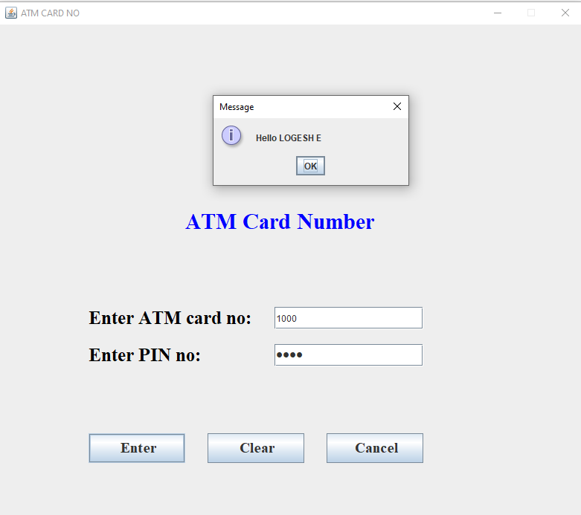

8

ACCOUNT TYPE:

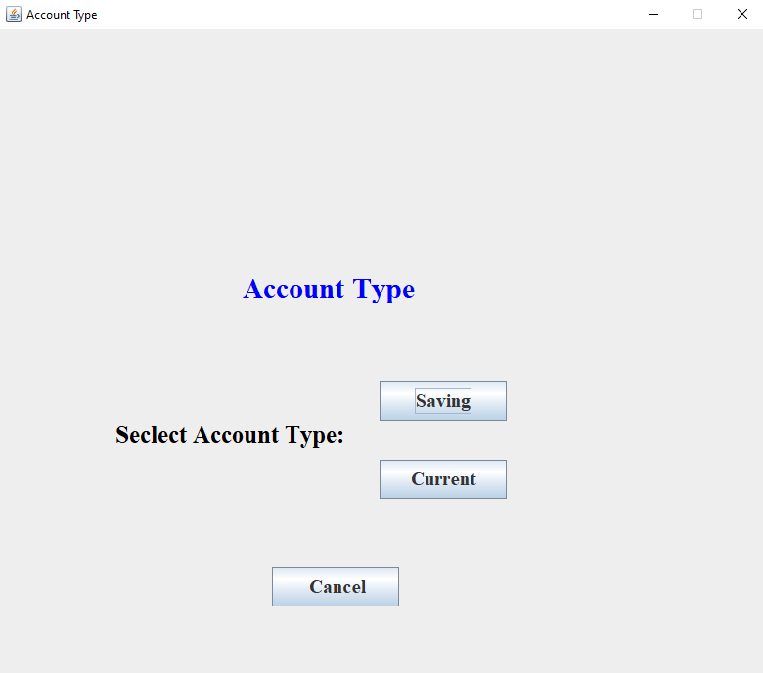

TRANSACTION MENU:

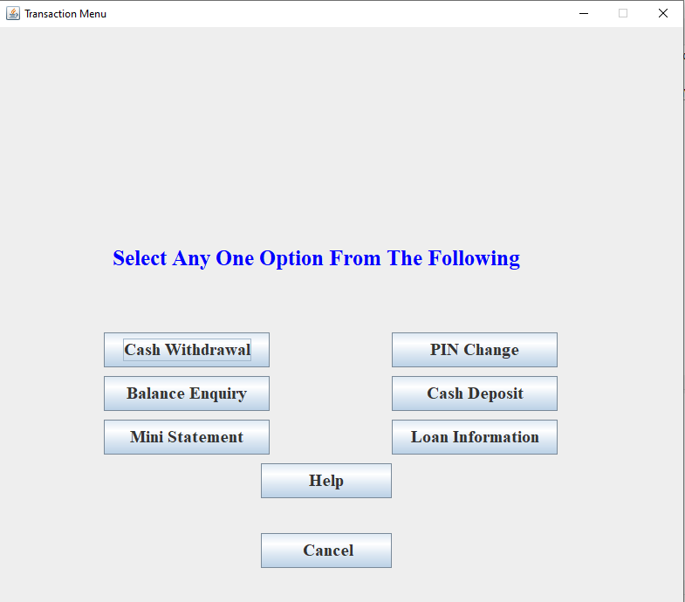

9

**Cash Deposit :**

Again, due to the strong cash culture in India, cash deposits are

most likely higher than in other markets, especially cash deposits made

by commercial customers such as retail shopkeepers and those whose

work involves substantial traveling. A high cash withdrawal rate results

in higher ATM servicing costs due to frequent cash replenishment

requirements. Recent developments in ATM technology have made it

possible to recycle cash in ATMs.

Currency notes received as cash deposits are counted; soiled notes

separated and deposited cash dispensed to fulfill withdrawal transactions.

However, regulatory concerns relating to identification of counterfeit

notes and its depositors need to be addressed first.

ATM with Cheque deposit facility is not picking up in India, like

other countries. One of the reasons is the delay in collection of the cheque

deposited in ATMs. Cheque deposited in ATMs is to be collected and

deposited in the designated branch for collection. Another reason is the

introduction of cheque deposit Kiosks by various Banks especially

Private sector ones. These are kept at each some important

locations/branches where customers can deposit there cheques which are

collected at intervals which may be difficult in ATMs.

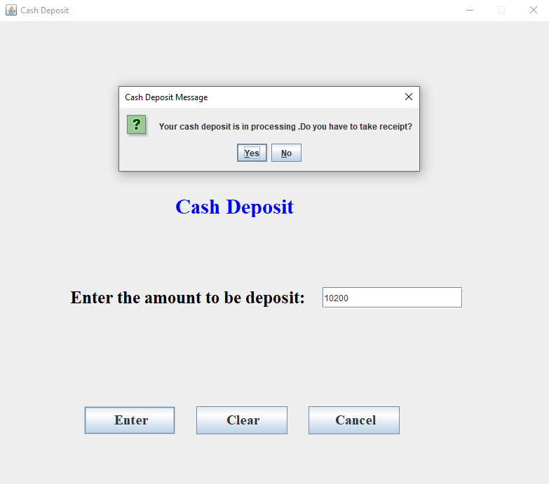

10

**Cash Withdrawal** :

In spite of a number of innovative services being made available at

many ATMs, cash withdrawal stills remains the most accessed service at

ATMs. However, the migration of routine bank transactions like cash

withdrawals and balance enquiries from teller counters to ATMs

significantly raises the potential for savings in employee costs and greater

employee focus on value-added revenue-enhancing activities such as

selling other financial products and advisory services to customers.



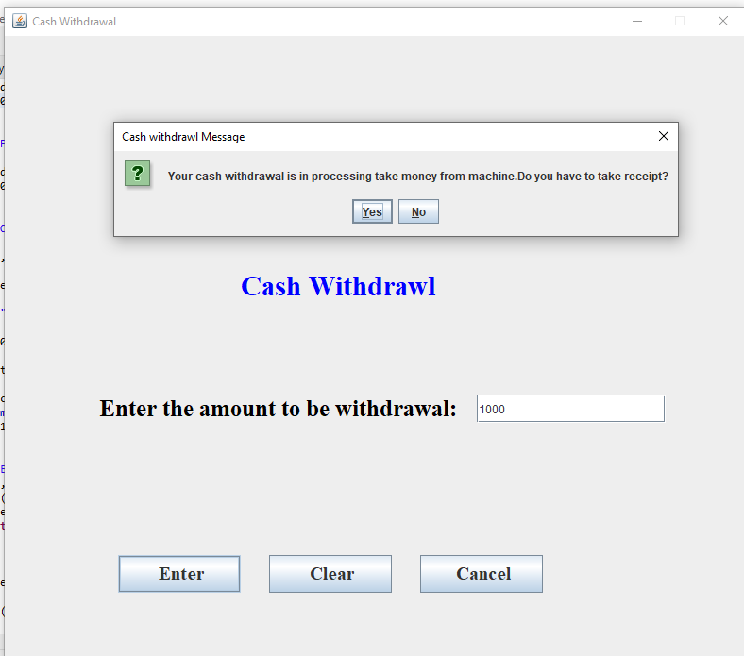

11

Balance Enquiry :

When users click the button “BALANCE”, it will show their current balance.

You can also check your account balance through an ATM. They also provide the updated account balance. By visiting the nearby ATM, you can insert the ATM card or debit card and follow the on-screen instructions. It is suggestible to use your own bank’s ATM or an ATM network which your bank uses. Usually, other ATMs charge fees even if you don’t withdraw cash. Also, your bank may charge additional fees if you use a foreign ATM. To check balance over a foreign ATM can be chargeable.

The steps following are the steps to check the balance in an ATM –

* Swipe the ATM cum debit card
* Enter the 4 digit ATM pin
* Select the “Balance Enquiry Option.”
* Finish the transaction

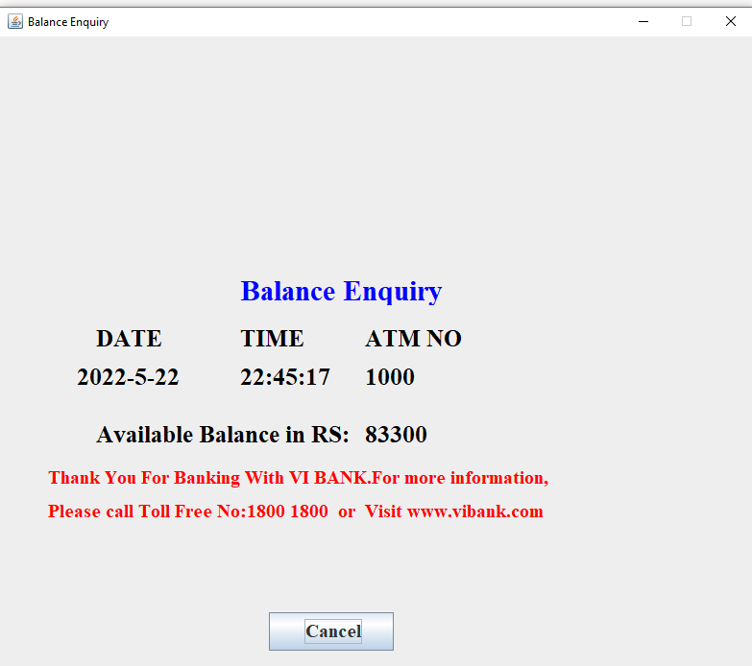

Mini statement :

The remarks of the transaction. On clicking on the transaction hyperlink, the details of the transaction are displayed. **The type of the transaction, whether debit or credit transaction.**

12

* **The amount or value of the transaction**.
* A cash machine mini statement shows your balance and the last **10 transactions** you've made

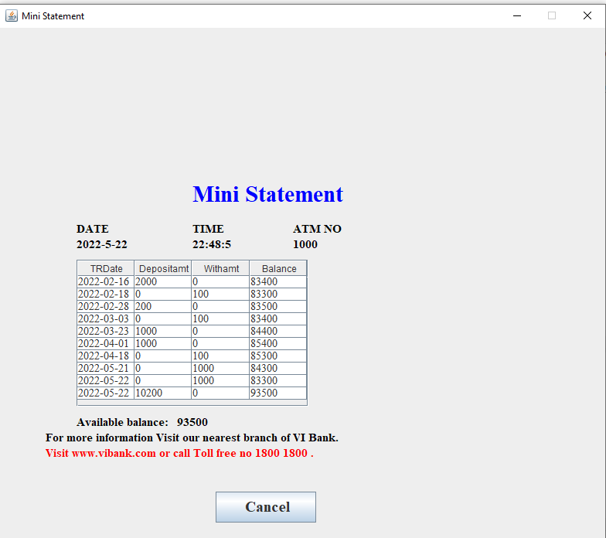

Pin change :

* Users can also change their password (pin). For that they need to click the button “**CHANGE PIN**”.
* It will show the screen for changing the pin where users need to enter their current username and password for verification. Then click the button “**CHANGE**”.
* It will appear a new J**OPTIONPANE**” for entering the new password.

Then click “**OK**”. It will change the current password to new password.

* Now when user start the program they will see the new password has been updated into the file. It will show in their console.
* **Choose Forgot PIN or Regenerate ATM PIN option on the menu**. You would be redirected to a screen to enter your registered mobile number, which triggers an OTP to that number. Enter the OTP on the screen, and you would be redirected to choose another PIN

13

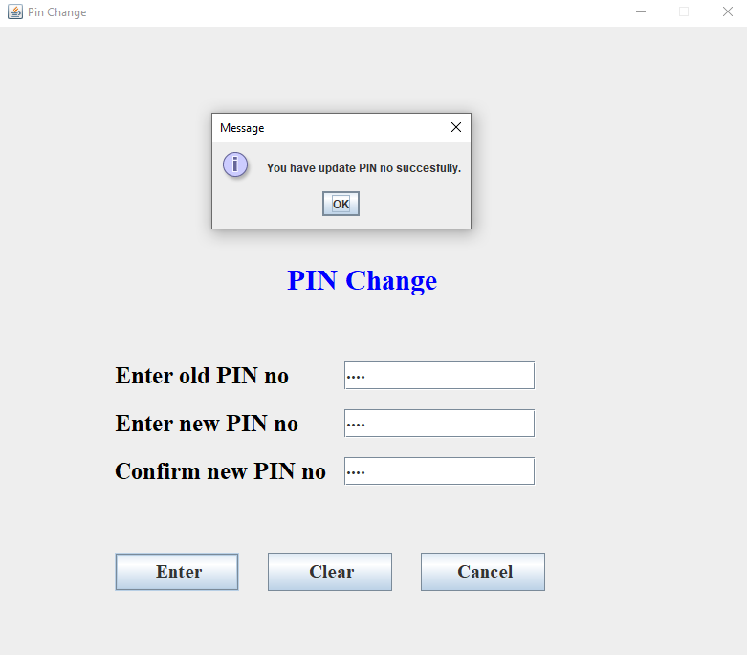

Loan information :

* **Once you complete the transactions such as cash withdrawal or checking balance, you can see a pre-approved personal loan offer on the ATM screen**. Many banking institutions, such as VI BANK are offering a pre-approved personal loan of up to Rs.80000.
* A loan is a sum of money that an individual or company borrows from a lender. It can be classified into three main categories, namely, **unsecured and secured, conventional, and open-end and closed-end loans**.
* A loan is **when money is given to another party in exchange for repayment of the loan principal amount plus interest**. Loan terms are agreed to by each party before any money is advanced. A loan may be secured by collateral such as a mortgage or it may be unsecured such as a credit card.
* check eligibility for EMI on the debit card, you can **call your bank's customer care number or send SMS**. Once you call or send a message to your lender, you will get the eligible loan amount and merchant name where the offer can be availed.

14

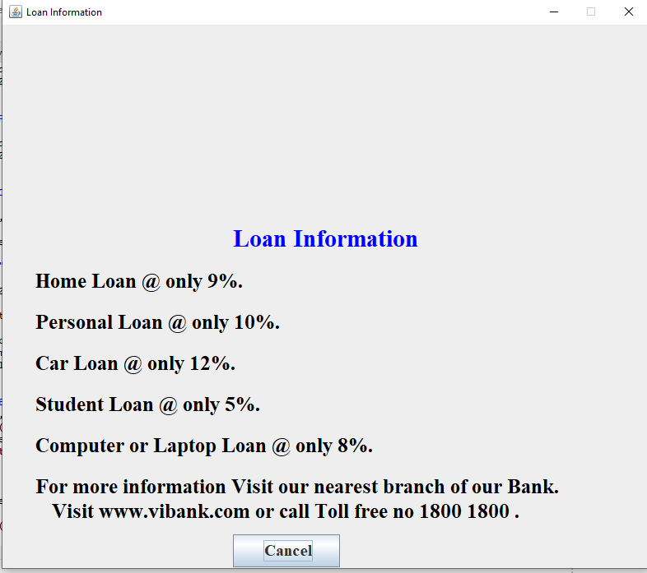

SOFTWARE DETAILS:

* ECLIPSE
* XAMPP
* MY SQL SERVER
* PhpMyAdmin server[localhost]

PHPMYADMIN:

* Php stands for pre Hypertext Processor
* It is an open source language so you do not need to buy any license or copy to install PHP on your machine.
* PHP community is very fast and solution for any technical problem can be found on internet , forum or blog.
* PHP is very much secured and PHP.net is keep releasing the latest verion and updates for the PHP for latest security updates and blugs being removed.

15

ECLIPSE

Features Of Eclipse IDE  
  
 **Provides excellent visual code debugging tool to debug the code**. Eclipse has a wonderful user interface with drag and drop facility for UI designing. Supports project development and administered framework for different toolchains, classic make framework, and source navigation

To use Eclipse for Java programming, choose "**Eclipse IDE for Java Developers**" (JavaSE) or "Eclipse IDE for Java EE Developers" (JavaEE). You need to first install JDK. Read "How to install JDK on Ubuntu". To use Eclipse for PHP programming, choose "Eclipse IDE for PHP Developers".

Eclipse is **one of the most popular Java IDEs on the market**. It's free, open-source, and has an extensive plugin ecosystem that allows users to customize functionalities for application development

Open the folder C:\Program Files\eclipse . **Right click on the Eclipse application ( eclipse.exe, with the little purple circle icon next to it) file icon and select Pin to Start Menu** . This creates a new shortcut in the start menu which you can now go to open Eclipse.

**How to create a new project**

1. Choose File -> New -> Project from the Eclipse menu bar, as in the following example:
2. The New Project wizard will appear, as in the following example:
3. Make sure "Java Project" is selected and click the Next button. ...
4. Congratulations, you have created your first Java project!

Current releases of Eclipse require **Java 11 JRE/JDK or newer**. A Java Development Kit (JDK) includes many useful extras for Java developers including the source code for the standard Java libraries

A Java IDE is **an integrated development environment for programming in Java**; many also provide functionality for other languages, IDEs typically provide a code editor, a compiler or interpreter and a debugger that the developer accesses through a unified graphical user interface (GUI).

16

XAMPP

* The term XAMPP is an apparent acronym. However, there is no official acronym expansion specified on the Apache Friends website. Their homepage header reads "**XAMPP Apache + MariaDB + PHP + Perl**", indicating that this abbreviation is a recursive acronym.
* XAMPP requires only one [zip](https://en.wikipedia.org/wiki/ZIP_(file_format)), [tar](https://en.wikipedia.org/wiki/Tar_(file_format)), [7z](https://en.wikipedia.org/wiki/7z_(file_format)), or [exe](https://en.wikipedia.org/wiki/EXE) file to be downloaded and run, and little or no configuration of the various components that make up the web server is required. The Windows version of XAMPP requires Microsoft Visual C++ 2017 Redistributable.
* XAMPP is regularly updated to the latest releases of [Apache](https://en.wikipedia.org/wiki/Apache_HTTP_Server), [MariaDB](https://en.wikipedia.org/wiki/MariaDB), [PHP](https://en.wikipedia.org/wiki/PHP) and [Perl](https://en.wikipedia.org/wiki/Perl). It also comes with a number of other modules including [OpenSSL](https://en.wikipedia.org/wiki/OpenSSL), [phpMyAdmin](https://en.wikipedia.org/wiki/PhpMyAdmin), [MediaWiki](https://en.wikipedia.org/wiki/MediaWiki), [Joomla](https://en.wikipedia.org/wiki/Joomla), [WordPress](https://en.wikipedia.org/wiki/WordPress) and more. Self-contained, multiple instances of XAMPP can exist on a single computer, and any given instance can be copied from one computer to another. XAMPP is offered in both a full and a standard version (Smaller version)
* The most obvious characteristic of XAMPP is the ease at which a [WAMP](https://en.wikipedia.org/wiki/WAMP) webserver stack can be deployed and instantiated.  Later some common packaged applications that could be easily installed were provided by [Bitnami](https://en.wikipedia.org/wiki/Bitnami).
* Officially, XAMPP's designers intended it for use only as a development tool, to allow website designers and programmers to test their work on their own computers without any access to the Internet. To make this as easy as possible, many important security features are disabled by default. XAMPP has the ability to serve web pages on the [World Wide Web](https://en.wikipedia.org/wiki/World_Wide_Web). A special tool is provided to [password-protect](https://en.wikipedia.org/wiki/Password) the most important parts of the package.
* XAMPP also provides support for creating and manipulating databases in [MariaDB](https://en.wikipedia.org/wiki/MariaDB) and [SQLite](https://en.wikipedia.org/wiki/SQLite) among others.
* Once XAMPP is installed, it is possible to treat a [localhost](https://en.wikipedia.org/wiki/Localhost) like a remote host by connecting using an [FTP](https://en.wikipedia.org/wiki/File_Transfer_Protocol) client. Using a program like [FileZilla](https://en.wikipedia.org/wiki/FileZilla) has many advantages when installing a [content management system](https://en.wikipedia.org/wiki/Content_management_system) (CMS) like [Joomla](https://en.wikipedia.org/wiki/Joomla) or [WordPress](https://en.wikipedia.org/wiki/WordPress). It is also possible to connect to localhost via FTP with an [HTML editor](https://en.wikipedia.org/wiki/HTML_editor).

17

MY SQL

* MySQL My SQL is an open-source relational database management system (RDBMS). Its name is a combination of "My", the name of co-founder Michael Widenius's daughter, and "SQL", the abbreviation for Structured Query Language. MySQL is free and open-source software under the terms of the GNU General Public License, and is also available under a variety of proprietary licenses. MySQL was owned and sponsored by the Swedish company MySQL AB, which was bought by Sun Microsystems (now Oracle Corporation).
* In 2010, when Oracle acquired Sun, Widenius forked the open-source MySQL project to create MariaDB.
* MySQL is a component of the LAMP web application software stack (and others), which is an acronym for Linux, Apache, MySQL, Perl/PHP/Python. MySQL is used by many database-driven web applications, including Drupal, Joomla, phpBB, and WordPress. MySQL is also used by many popular websites, including Facebook, Twitter, Flickr, and YouTube







18

XAMPP PhpMyAdmin

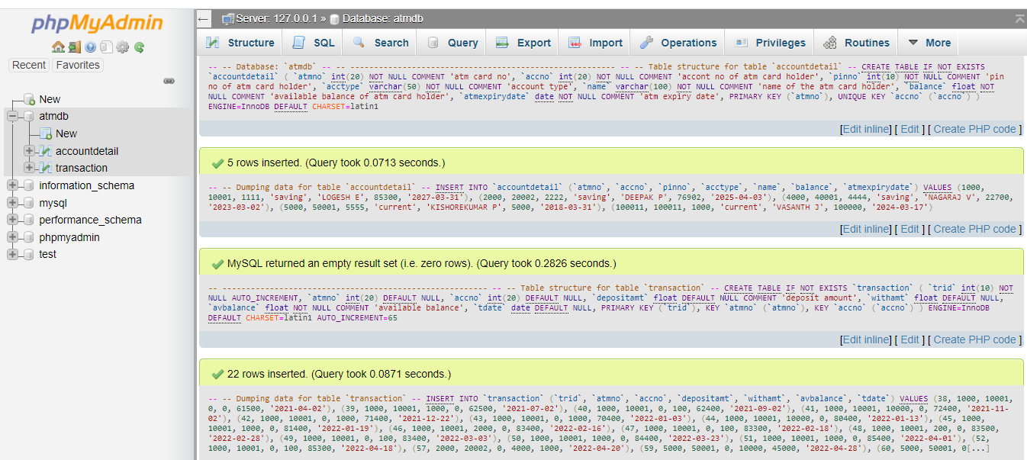

Eclipse workplace :

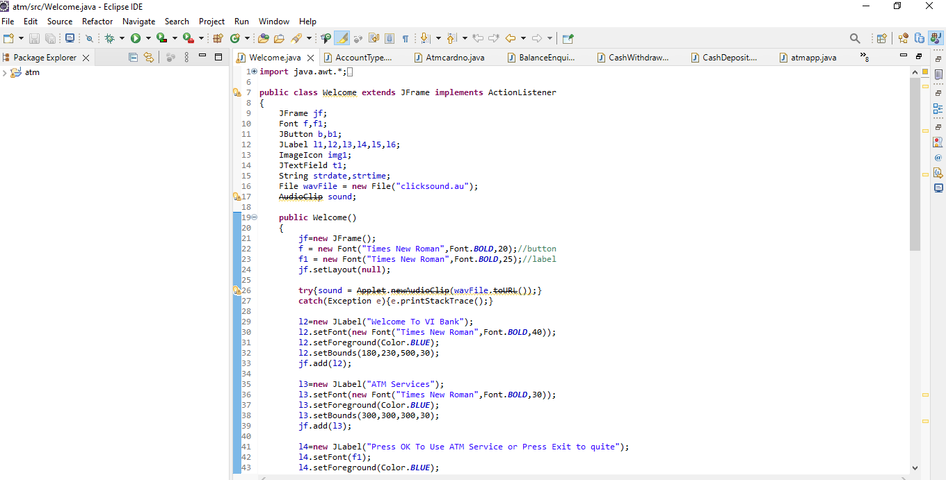

19

FLOW CHART :

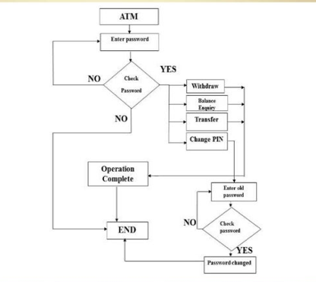

20

ARCHITECTURE OF ATM SYSTEM

PIN CHANGE

LOAN INFORMATION

IMINI STATEMENT

CASH WITHDRAW

CASH

DEPOSIT

BALANCE ENQUIRY

LOGIN SCREEN

MAIN MENU

ATM SYSTEM

CONCLUSION:

* The Project on the “ATM MACHINE” Has ben developed as the best flexible and efficient project within the available resources and time.
* In future we are planning to add new features like figure print Reader and Eye detection system for Authendication of user Security purpose.
* Care has been taken at each step to make it more user friendly so that users can add new features where ever necessary while using this automated system.
* The ATM’s have gained worldwide popularity within a few years. ATM

machines are easy to operate and hence, attract more and more customers.

There are quite of innovations, which are being taken place in the ATM

machine.

* ATM machine also makes it convenient to deposit money, transfer money, and check balances. Best of all, to use an ATM machine, we do not have to go to the bank.
* We will find ATM machines at other banks, grocery stores, shopping malls, along the roadside, Buckingham Palace, airports, in casinos, and even on the South Rim of the Grand Canyon. For this reason, ATM machines are extremely helpful!
* The locations of ATM’s are the key location of any particular area.
* ATM’s is a form of easy banking. The aim of banks of setting of ATM’s is to cater to the needs of the customers. The flexibility of the ATM’s has increased so much that now-a-days, have been reached the doorsteps of the customers. The customers using the ATM machine are satisfied with the service and have very less complaints about the machines.

22

REFERENCE:

* DREAMCODE.NET, 2014. *DREAMCODE.NET.* [Online] Available at: http://www.dreamincode.net/forums/topic/206344-basic-gui-in-java-using-jframes/ [Accessed 5 December 2014].
* EXAMPLES.JAVACODEGEEKS, 2014. *EXAMPLES.JAVACODEGEEKS.* [Online] Available at: http://examples.javacodegeeks.com/desktop-java/swing/jbutton/set-action-command-for-jbutton/ [Accessed 5 December 2014].
* HOME&LEARN, 2014. *HOME&LEARN.* [Online] Available at: http://www.homeandlearn.co.uk/java/read_a_textfile_in_java.html [Accessed 5 December 2014].
* JAVA2S, 2014. *JAVA2S.COM.* [Online] Available at: http://www.java2s.com/Questions_And_Answers/Java-File/text-file/password.htm [Accessed 5 December 2014].
* NETBEANS.ORG, 2014. *NETBEANS.ORG.* [Online] Available at: https://netbeans.org/kb/articles/gui-functionality.html [Accessed 7 December 2014].
* ORACLE.COM, 2014. *docs.oracle.com.* [Online] Available at: http://docs.oracle.com/javase/7/docs/api/javax/swing/JFrame.html [Accessed 5 December 2014].
* PROGRAMCREEK.COM, 2008. *PROGRAMCREEK.COM.* [Online] Available at: http://www.programcreek.com/2011/03/java-write-to-a-file-code-example/ [Accessed 5 December 2014].
* REALAPPLETS.COM, 2014. *REALAPPLETS.COM.* [Online] Available at: http://www.realapplets.com/tutorial/actionexample.html [Accessed 5 December 2014].
* STACKOVERFLOW, 2011. *stackoverflow.* [Online] Available at: http://stackoverflow.com/questions/4716503/best-way-to-read-a-text-file [Accessed 6 December 2014]

23